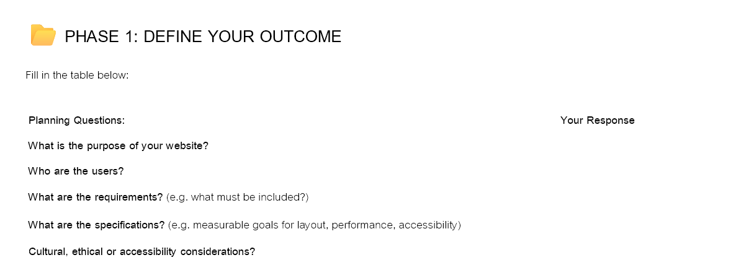

**Purpose of the Website**

To show information and a trailer for our horror game, and help market it to the public.

**Users**

Anyone aged 15+ who enjoys horror games or movies. The game is R15 due to disturbing themes.

**Requirements**

Users come to the site for entertainment and to learn about the game.  
We meet this by:

* Showing a trailer
* Giving background info
* Adding leaderboards to track top scores
* Inclusive environment for all cultures and people

**Specifications & Considerations**

* The game is set in a Soviet hospital in 1976 — it's fictional, not political
* Disturbing content is used responsibly
* Subtitles and accessibility features will be included
* The design matches the dark horror theme
* Works on all devices
* Use Html CSS and java script to create an interactive website.

